**Instanceof methods-**

Same error for this line-

**Casting examples-**

**Run time polymorphism-**



If the method name itself is **different** or **not present** in **child class-**

**Upcasting-**



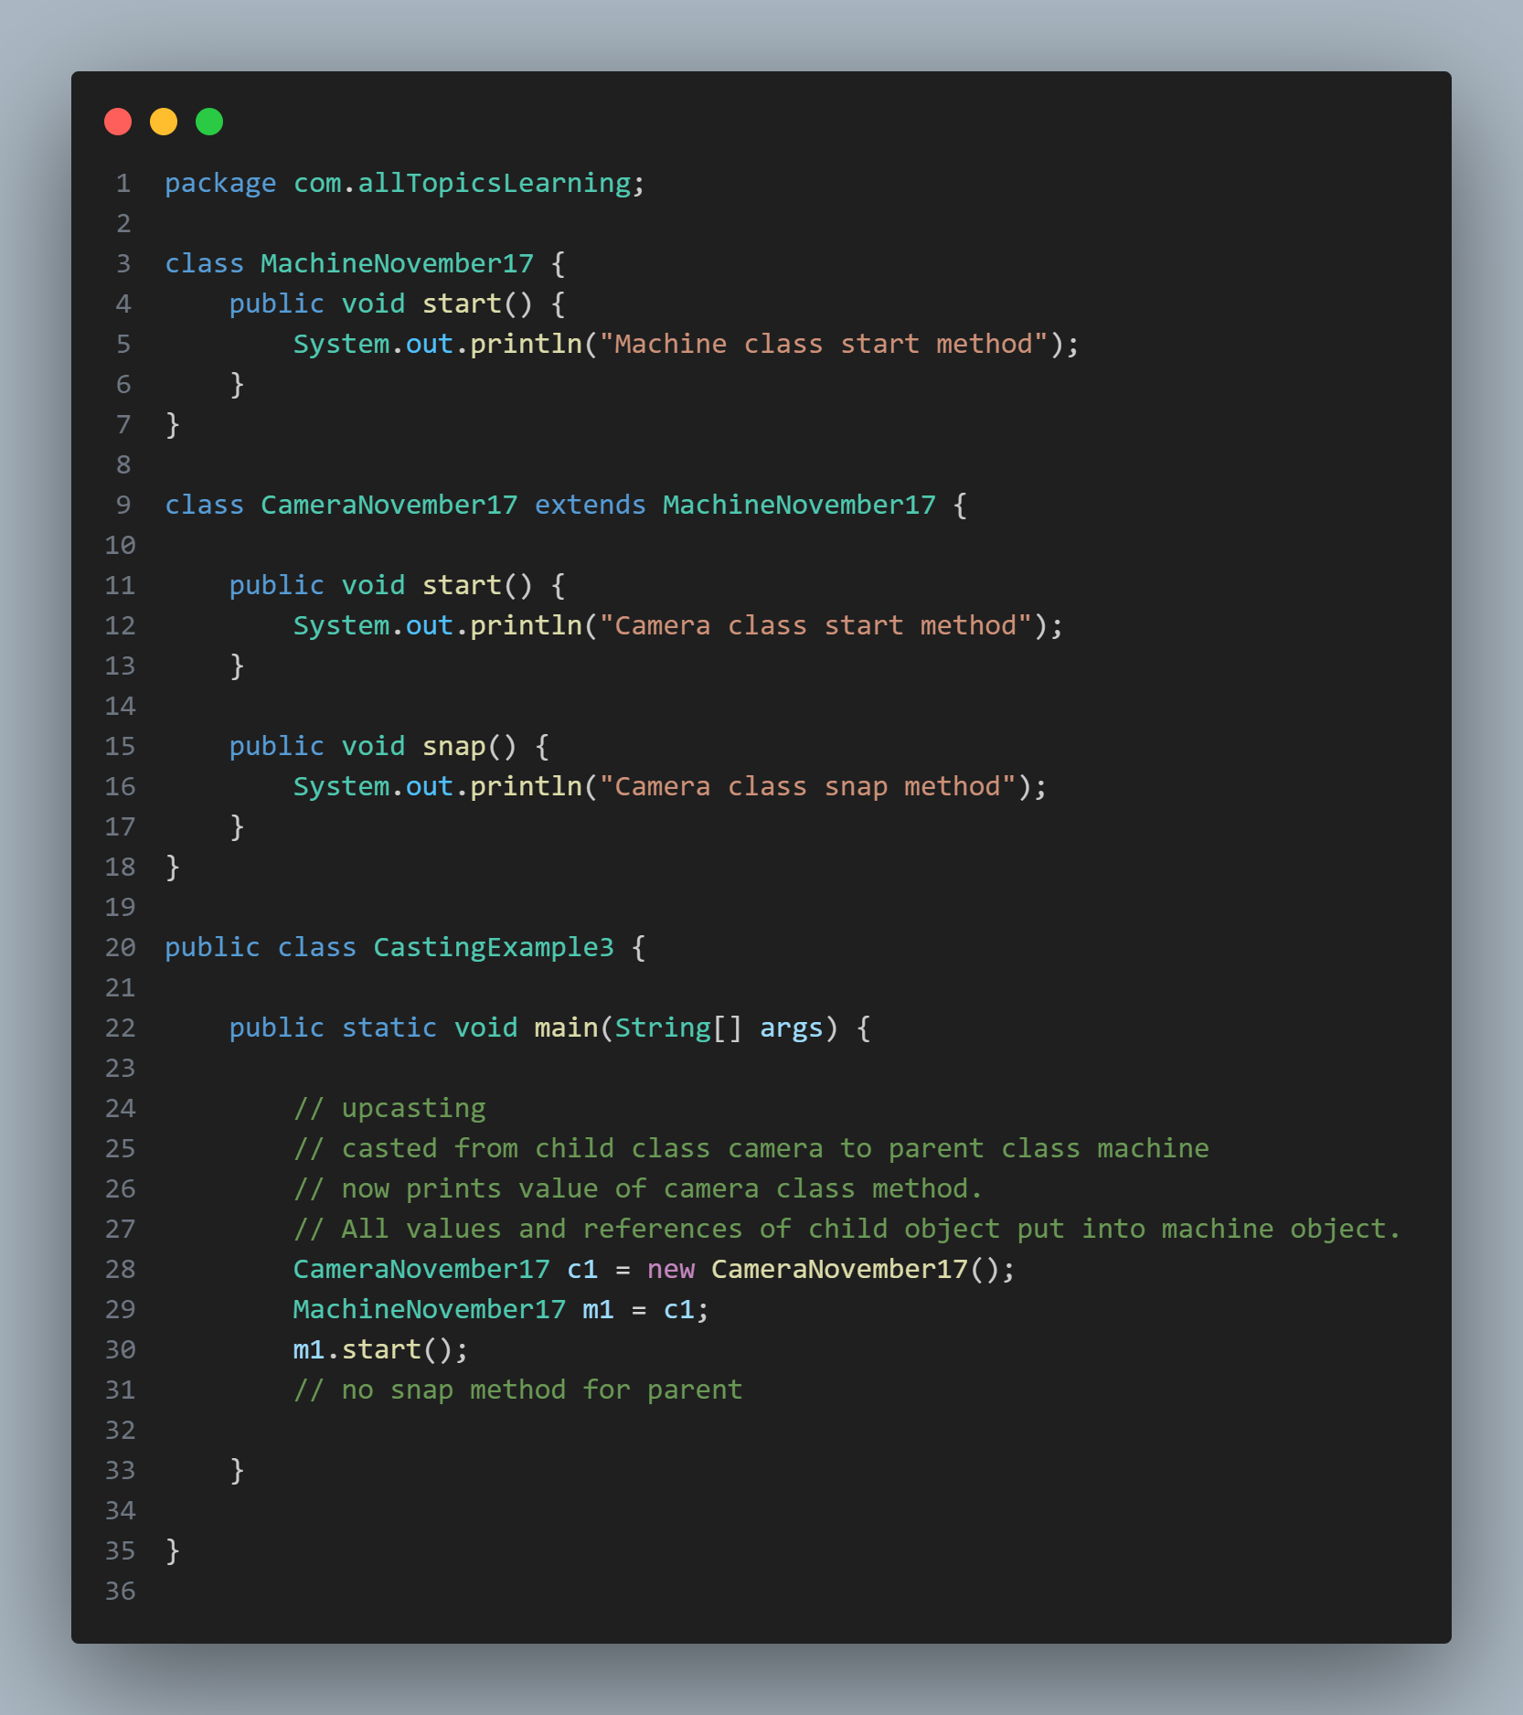



**Downcasting-**



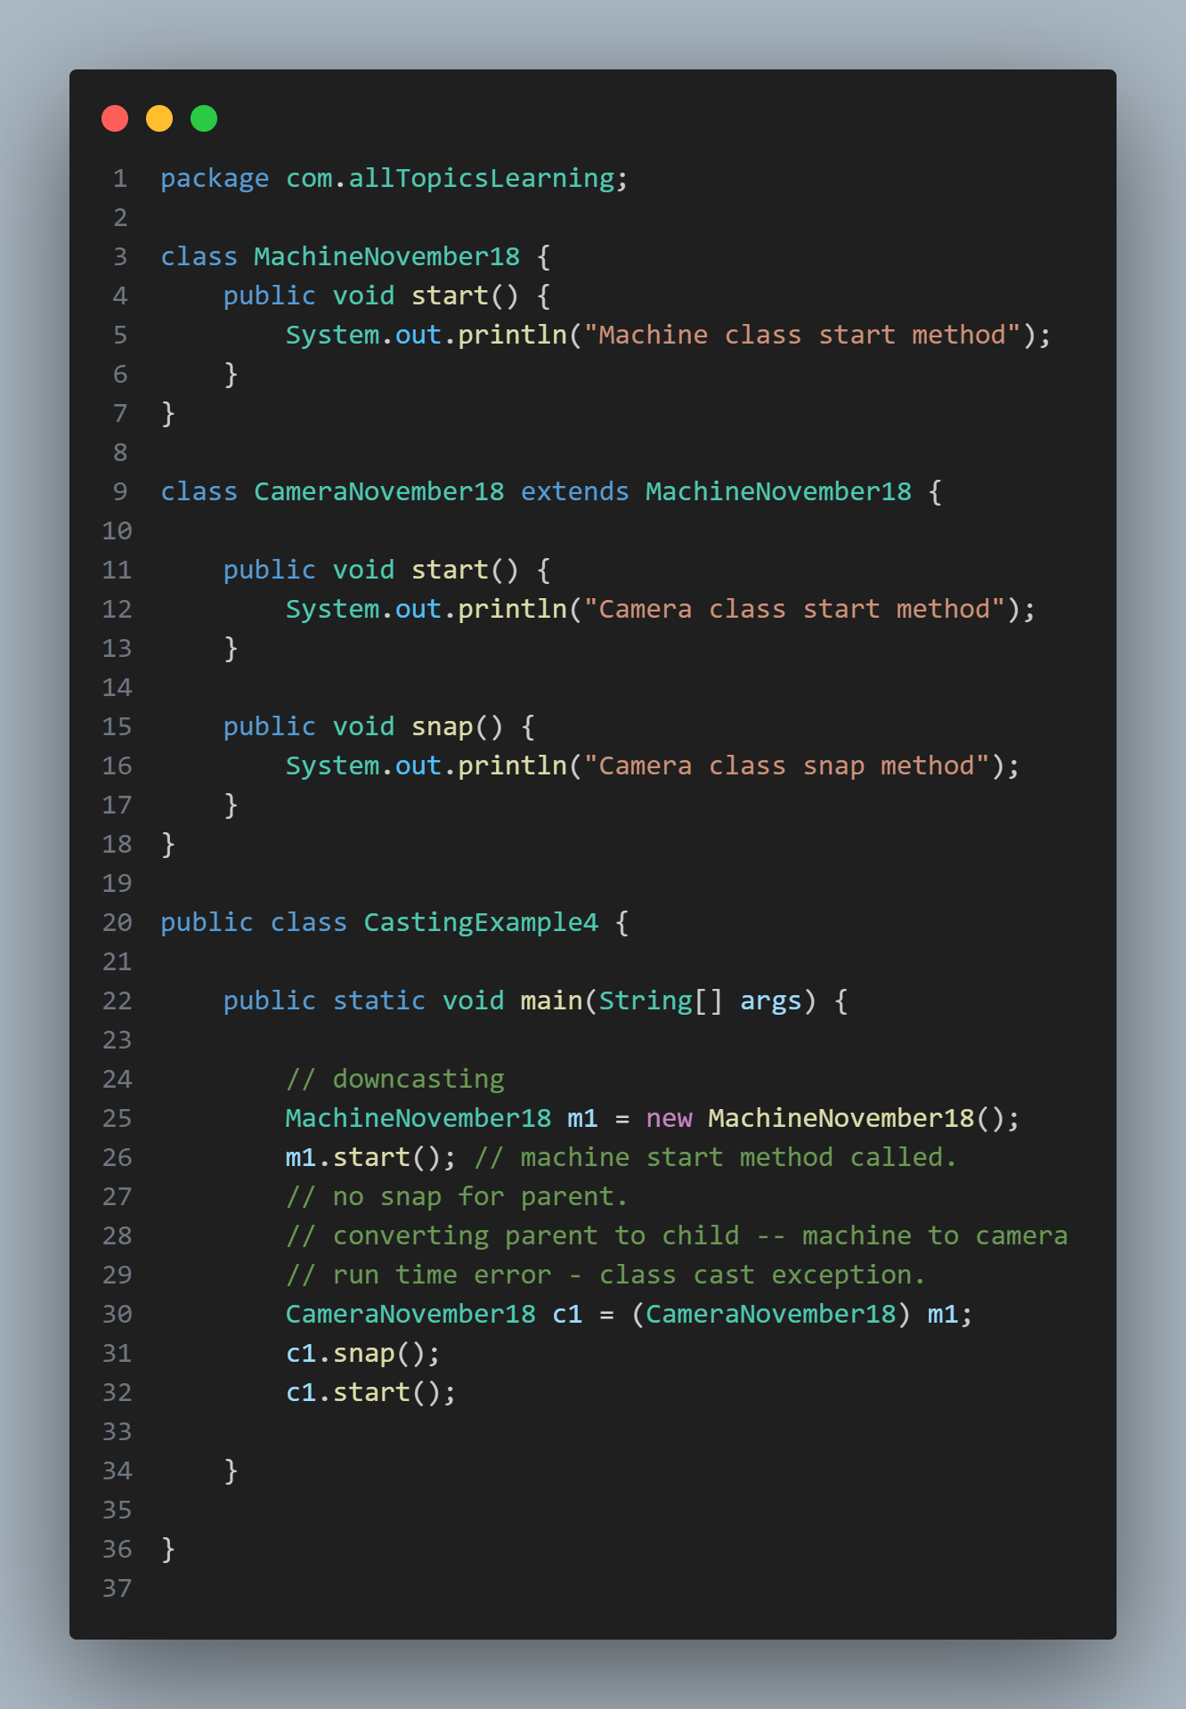

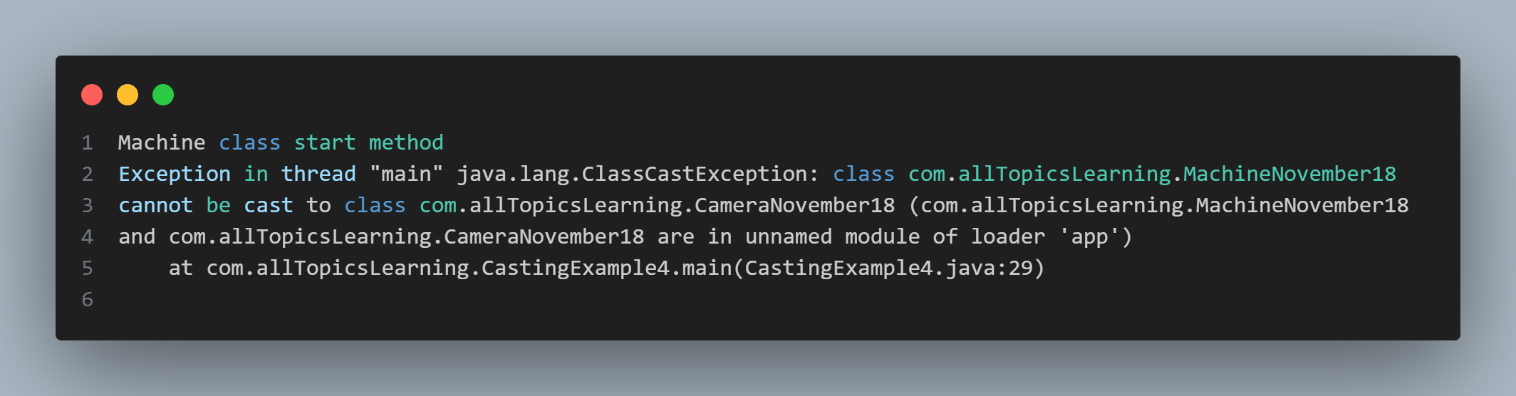

To remove the exception of **class cast** which we get in **downcasting,** we change code as below-



**How to check instance along with downcasting-**

**Lets see in upcasting also-**

